The descriptive analysis at the country level shows that the development of RETI is heterogeneous. As an example, China and the United States consistently lead in the number of patents in renewable energy, whereas countries such as India and South Korea have experienced a significant increase after 2010, likely due to a specific focus on energy reforms and digital infrastructure development. Conversely, Germany and France are showing plateauing trends, implying saturation or policy change. These trajectories affirm that there is no uniformity in RETI dynamics within the M8 and that it should be interpreted given country-specific governance, policy, and economic frameworks.

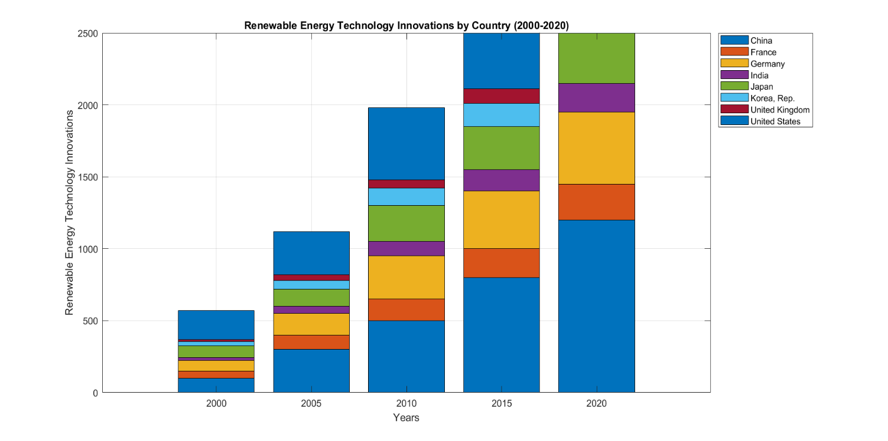

Fig. 3. Evolution of RETI in M-8 countries.

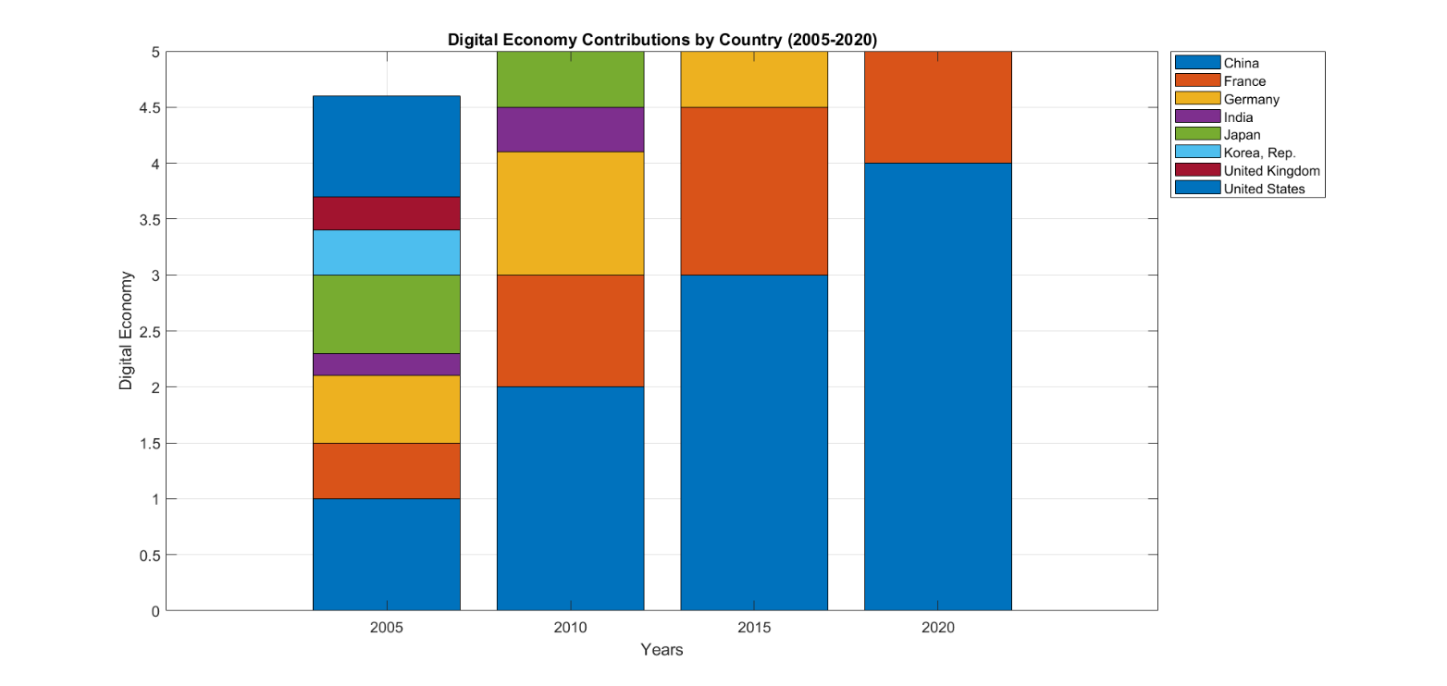

Fig. 4. [Making digital](https://www.sciencedirect.com/topics/social-sciences/digitalization) of [economic systems](https://www.sciencedirect.com/topics/economics-econometrics-and-finance/economic-system) in M-8

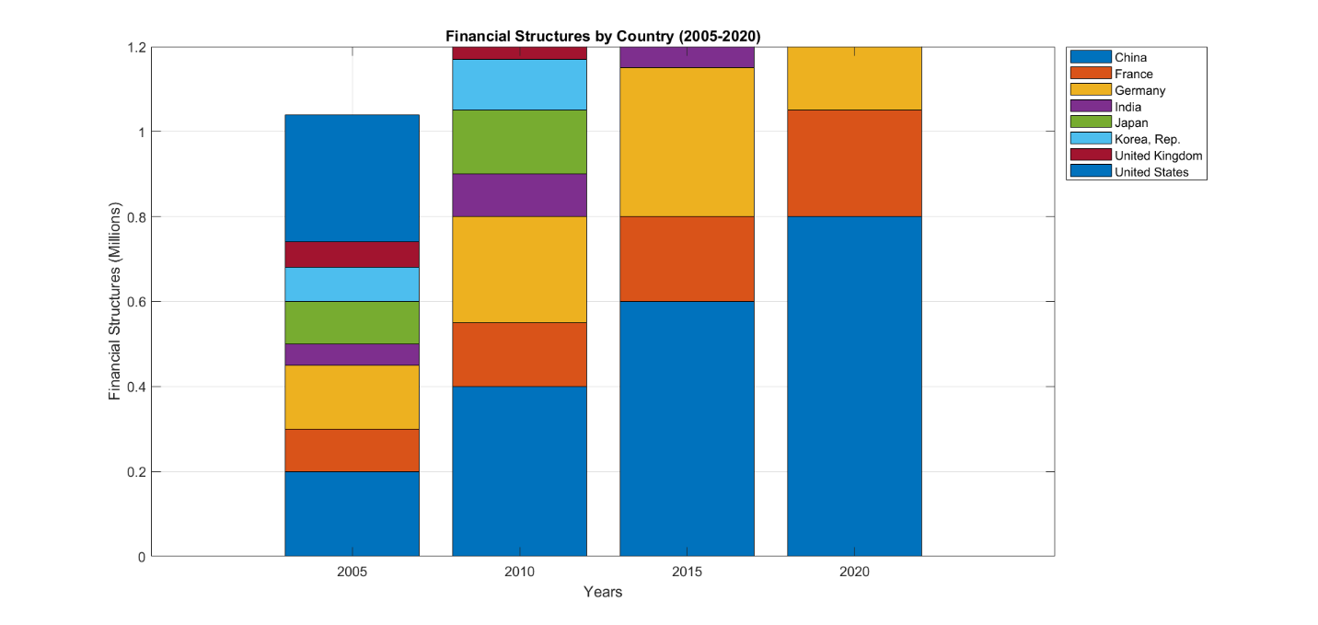

Fig. 5. Evolution of financial frameworks in M-8

4.2. Assessment Methods Diagnostic tests were conducted prior to the estimation of the panel models to ascertain the validity of the econometric approach. The Pesaran CD test was used to determine the extent of cross-sectional dependence (CSD), indicating that there was indeed significant cross-sectional dependence among the M-8 countries. This finding highlights the appropriateness of using estimators that are robust to cross-sectional dependence. A slope heterogeneity test (Pesaran & Yamagata, 2008) also suggested variability of parameters across cross-sections, which points to the desirability of models in which slope parameters may be heterogeneous.